BATTERY CONDUCTANCE TESTER
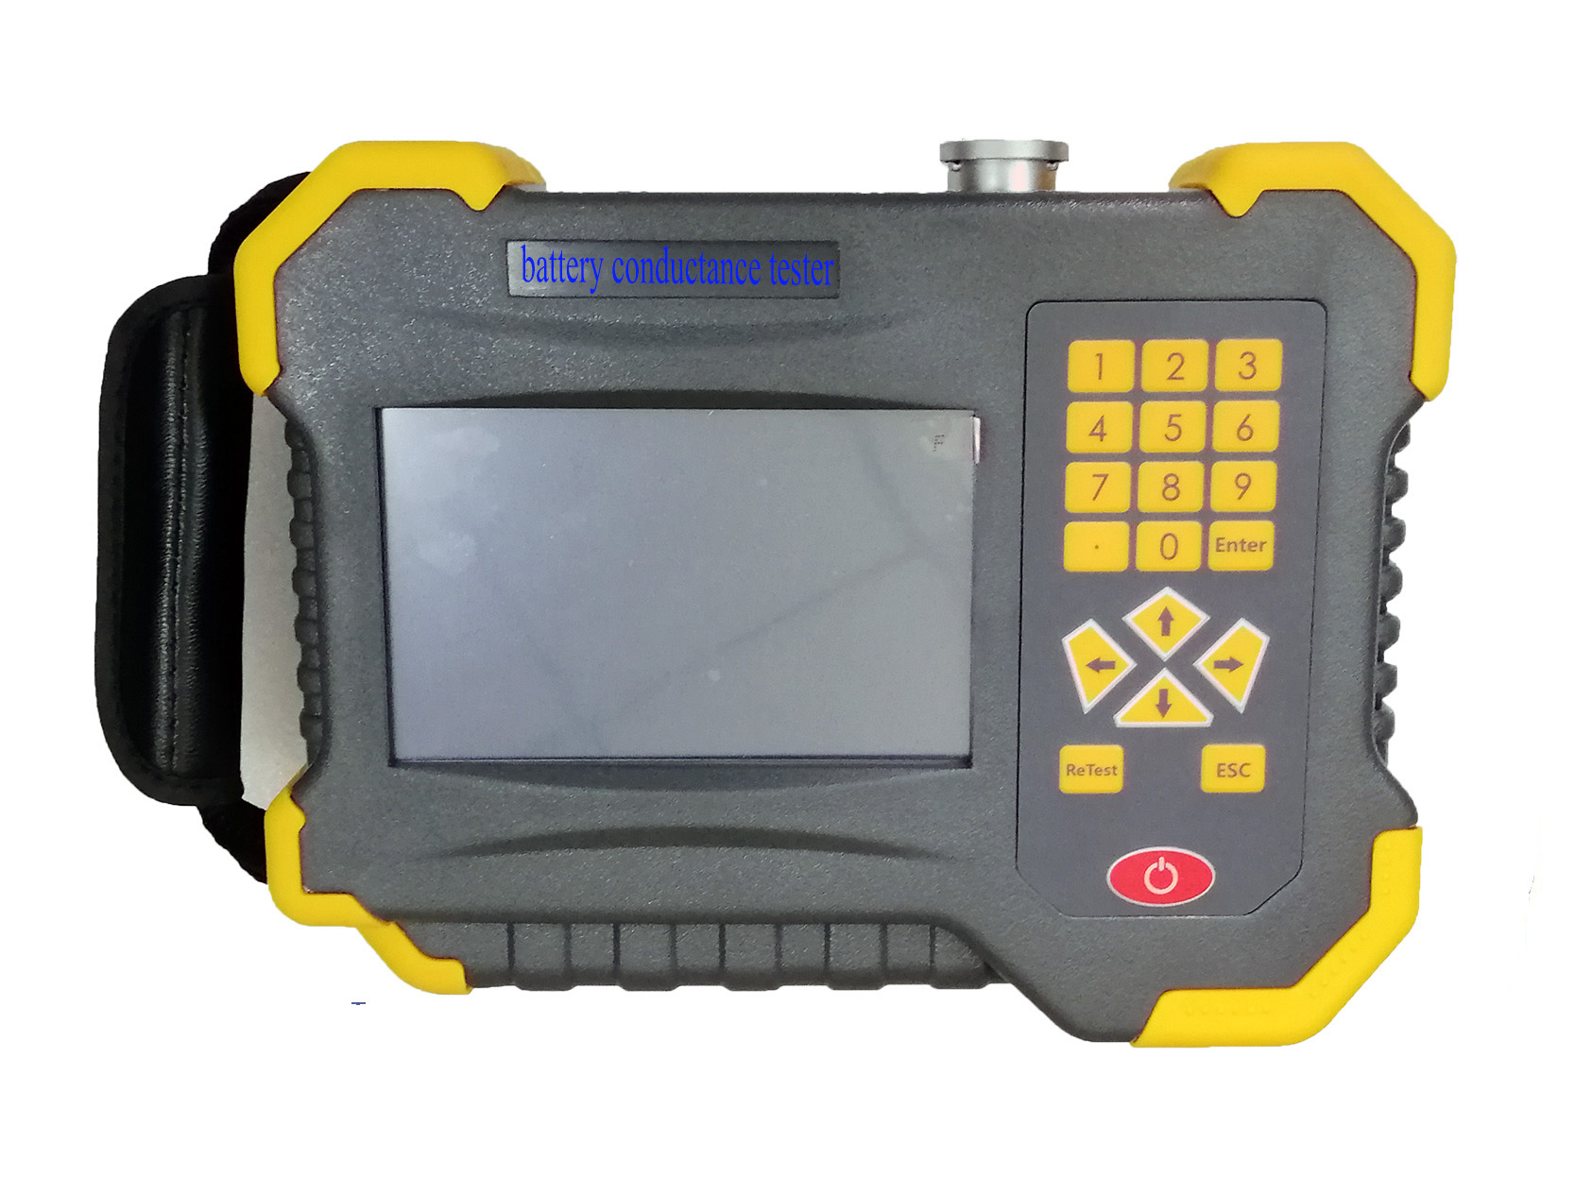
OR-10 Battery Internal Resistance Tester is a multi-function and portable instrument, which can test battery running condition and parameters quickly and precisely. It can display and record many key parameters for multi battery string and battery cell’s voltage, internal resistance, conductance value. From these parameters, can know the battery condition is in good or bad. Which can connect with PC, use professional analysis software to make the format to record and follow up the battery condition change, so that technical and management person to know in advance, then they can do maintenance work for battery.

MAIN FUNCTIONS AND FEATURES
Main Functions
- Test the battery voltage, conductance and internal resistance online.
- Battery Conductance,internal resistance and Voltage out of range alarm.
- Battery parameters are marked by group No. to data management expediently.
- PC analysis software to realize record and follow up battery condition.
- Wide range application in industrial, telecommunication, Automotive, UPS, etc
Key Features
- High precision online testing, full automatically switch the testing range, large data storage
- Storage 999 group testing data (each group 999 batteries at most)
- Storage 500 groups battery setting parameters
- Battery capacity testing range: 5AH-6000AH
- Measure DC voltage and conductivity of cell at the same time
- 5inch color touch LCD screen
- Display the graph and bar charts analysis function
- Battery capacity analysis function, do the excellent, good, bad analysis
- Oscilloscope function: indicate the highest, lowest and average voltage, count the voltage wave
- Transmit the testing data to PC to carry out analysis of battery according to the history data.
- Strong data management function, do not connect with PC, can use
- Enhanced over voltage protecting function.
- Automatically recovery the over current protecting function.
- Use the SOC chip to improve the tester stability.
- Large capacity Lithium and power adapter to ensure the power supply
- Low battery indication to guarantee test precision
- Small volume, light weight
- Reverse polarity protection
- Automatic testing mode, for user convenience
- Automatically analyze and judge the battery condition
- Building the history database, describe the battery life span curve.
- Contrastive analyzing for each battery cell within the same battery string.
- All batteries are administrated by different SOH (excellent, good, medium and bad)
SPECIFICATION
Description | Parameter
Testing Range | Conductance: 20-19990S  Internal Resistance :0.000mΩ-99.999mΩ  Battery Voltage: 1.2V/2V/6V/12V
Measurement Resolution | Conductance: 1S  Internal Resistance :0.001mΩ  Voltage: 1mV
Measurement Precision | Conductance/Internal Resistance : ±0.5%rdg ±6dgt  Voltage: ±0.2%rdg ±6dgt
Power Supply | 11.1V,2400mAh, rechargeable lithium battery
Battery Life | Work for 8 hours continuously
Storage Capacity | 64Mbit Flash+ 4GSD
Display | 5 Inch color touch LCD screen with blacklight
Size | 220 x 170 x 52mm
Weight | 1.1Kg
Temperature | 0 – 40ºC
Humidity | 5 - 95% RH (No condensation).
PACKING LIST
No. | Items | Q’ty
1 | Battery Tester | 1 unit
2 | Operation manual | 1 copy
3 | Product Certification | 1 copy
4 | Packing list | 1 copy
5 | Rechargeable battery | 1 unit
6 | Power supply adapter | 1 unit
7 | Testing Clamp (standard) | 1 unit
8 | Testing lead (optional) | 1unit
9 | SD card | 1 unit
10 | SD card reader | 1 unit
11 | Carry bag | 1 unit

